Nimbus Framework Architecture - Technology Usage

- Overview
  - Purpose:
The purpose of this document is to detail about couple of technologies that are being used by the Nimbus Framework.
  - Scope:
The technologies i.e., Spring and Angular JS used by the Nimbus framework are in scope and the rest of the technologies are not being captured in this document.
  - Target Audience:
The technical panel of tetra soft.

- INTRODUCTION
The following screenshot depicts the product tech stack being used by Nimbus framework and yellow color highlighted technologies usage in Nimbus framework are explained in the below section.
Screenshot:
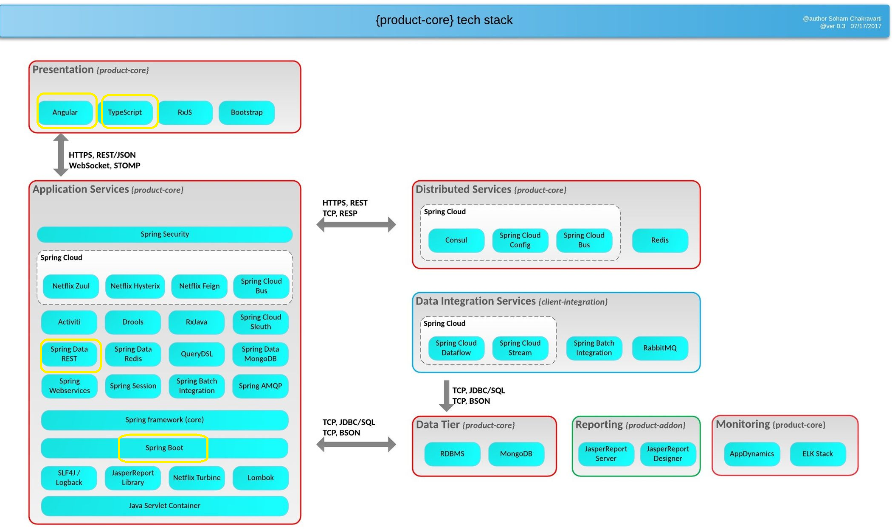
- Specific focus on highlighted technologies:
Spring data REST, Spring Boot , Angular JS and Typescript are focused here for the explanations.
  - Spring data REST:
In general, Spring Data REST is part of the umbrella Spring Data project and makes it easy to build hypermedia-driven REST web services on top of Spring Data repositories.
- Nimbus Framework requires typical CRUD operations to communicate its downstream systems to make sure the data transfer happens through a JSON and the ultimate aim of JSON data transfer between two applications is faster and loosely coupled with the use of microservices.
- Also http communication between two rest calls is state less, so that all the calls will serve only its purpose and optimistic usage of the domain model.
- The below Controller is a RestController in Nimbus framework and the end points defined in this controller is to perform CRUD operations and it support JSON request and response.
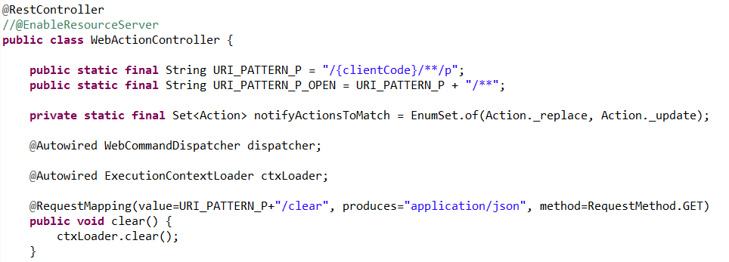
  - Spring Boot:
- In general, Spring Boot makes it easy to create stand-alone, production-grade Spring based Applications that you can "just run".
- Nimbus Framework used Spring Boot application to make minimum viable product “(MVP)”.
- Spring Boot allows the product related dependencies at the spring container level at the server startup.
- In spring boot application, the classes like @Configuration, @Component, @Service and @Repository can be easily utilized by Nimbus framework product to define their dependencies.
- By default Spring Boot uses Tomcat / Jetty server to make sure the production copy can be teseted with the single standalone spring boot application. It helps the developer to easily develop their services with the less interaction of multiple deployment activities. It also eases the unit testing strategy (both test driven and behavioral driven approaches).
- There is a technique called component scan to go over the spring boot family classes and tells the spring container the kind of the action to be performed at the runtime.

The below classes are Spring Boot configured core classes in different modules of Nimbus Framework.

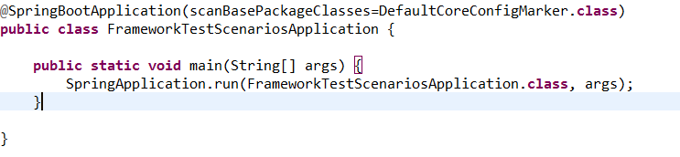
And

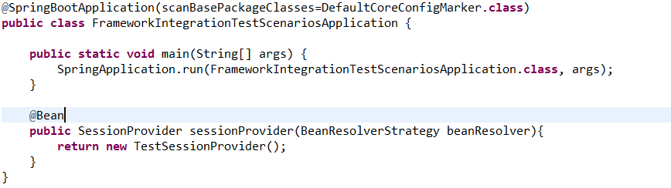
  - Angular JS:
- Nimbus Framework uses Angular JS as a front end technology to implement the view layer.
- API calls are triggering from angular client application and contacts view state of backend application in Nimbus Framework and getting the response.
- Here, the main data transfer between client and server application is in JSON format.

  - Typescript:
- Nimbus framework uses typescript language to develop the angular js components.
- And also the preferable script is typescript to implement angular js client application.
- In general, after compilation typescript files will be converted to JavaScript files.

